PuSh International Performing Arts Festival
January 19 - February 5, 2023 | pushfestival.ca

As we welcome blind and low vision arts lovers to our festival, we provide:
- Live description by VocalEye
- We work with our Low Vision Consultant, Kristy Kassie to curate our Low Vision Friendly programming
- Introductions providing additional context for shows without live description
- Sighted guides can be requested to pick you up at the nearest transit stop (for any show)
- We are part of the Access2 program and offer complimentary companion tickets
If we can support you in any other way, please don’t hesitate to get in touch.

This is a List of Shows Accessible for the Blind and Low Vision Community

A PERCUSSIONIST’S SONGBOOK
This show is Low Vision friendly, it is a concert.
By JOBY BURGESS from the UK
Percussionist Joby Burgess performs his new album of “songs without words.” The virtuosity, range and creativity on display are downright thrilling.
Show runs on January 25th and 26th at 7:30pm
Where? at Orpheum Annex | Price $34

AFTERNOW
This event is Low Vision friendly, it is a sound installation.
By NORA CHIPAUMIRE from ZIMBABWE and the USA
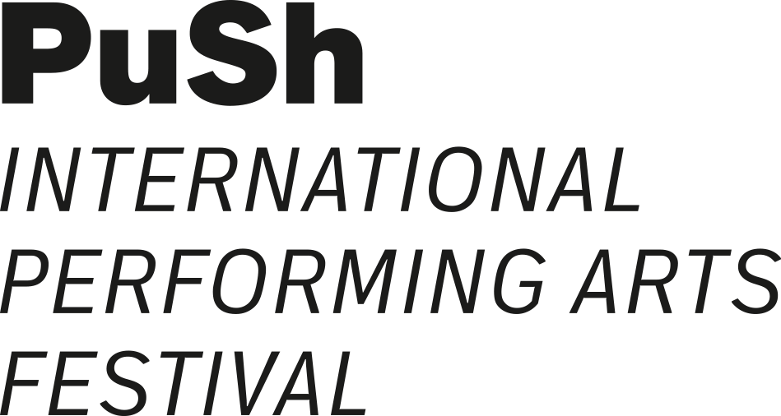
Loud, proud and militant, this installation features beautiful video portraits, contemporary opera and one booming stereo system.
Installation runs January 28th till February 5th, open from 12 to 7:30
Dub nights are on January 28th and February 1st from 9 to 11:30
Where? at Roundhouse Exhibition Hall | Visiting this installation is FREE

OKINUM
This show will be live described with a touch tour on February 3rd.
By PRODUCTIONS ONISHKA WITH ANAKU AND KVS PRODUCTION from CANADA
Émilie Monnet interprets a recurring dream and attempts to reclaim her Anishinaabe ancestry in this hypnotic monologue performance.
Show runs in-person on February 2nd and 3rd at 7:30, and online on February 2nd till February 5th.
Where? at Anvil Theatre | Price $34 for in-person and $25 for online tickets

RED PHONE
This experience is accessible to people who are partially sighted and can read short texts (green letters, 1 inch high on a black background) and accessible to braille users (this is the pilot project to use braille for this show)
By BOCA DEL LUPO from CANADA
Immersive experience in a phone booth. Two at a time, audience members engage with another unseen partner in a scripted 8-10 minute conversation from two separate booths. Step inside a phone booth, and imagine yourself in a new life, acting out evocative discussions, reading aloud conversations with a fellow audience member.
Performance runs January 29th till January 31st and February 2nd till 4th, open from 3 to 7, runtime is between 3 to 15 minutes.
Where? at The Fishbowl | Visiting this performance is FREE, no need to book just show up
(for the braille version you can book)

THE SEVENTH FIRE
This experience is an audio experience
By DELINQUENT THEATRE / FULL CIRCLE FIRST NATIONS PERFORMANCE / PUSH FESTIVAL, IN ASSOCIATION WITH NEWORLD THEATRE from the UNCEDED COAST SALISH TERRITORIES, MST
Take a journey into the realm of Anishinaabe tradition with this immersive audio experience in a 4D audio. An immersive audio performance inspired by ceremony from Anishinaabe stories.
Show runs from January 25th till February 4th at various times
Where? at Lobe Studio on Hastings street | Price $34

- Accessible seating can be reserved or priority seating is offered
- Complimentary tickets for companions are available for Access2 cardholders or VocalEye members Call our box office at 604.449.6000
- Sighted guides to provide support getting from local transit to and from the venues
are available for all shows and events
For VocalEye described shows, request at buddies@vocaleye.ca
For any other shows, contact access@gmail.com or call 604.605.8286 ext 204
- Great discounts for group bookings saving up to 30%

For more details and to discuss accessibility needs contact:
Accessible PuSh Coordinator, Anika Vervecken
access@pushfestival.ca | 604.605.8286 ext 204

